**Naan Mudhalvan**

**Digital Marketing**

**Name:** Siva Kumar R

**Nm ID:** au913120104307

**ASSIGNMENT – 1**

**LINKEDIN PROFILE:**

* Create or log in to your LinkedIn account.
* Add a professional photo, customize your URL, and write a concise headline.
* Craft a brief summary highlighting your skills and background.
* List your work experience and educational history.
* Add key skills and seek endorsements.
* Request and receive recommendations.
* Connect with people, engage in your network, and follow relevant interests.
* Adjust privacy settings as needed.
* Keep your profile current to reflect your career journey

**Profile:**

**ASSIGNMENT – 2**

**BRAND NAME:**

* Understand your values and audience.
* Create unique, memorable, and clear options.
* Ensure it's legally and online available.
* Get feedback for resonance.

**BRAND NAME :** ASCUBE

**INSPIRATION:** MEESHO

**ASSIGNMENT – 3**

**FACEBOOK PAGE:**

* Create a brand logo
* Design banners for the facebook page
* Create a business page in facebook

BRAND LOGO:

**FACEBOOK PAGE**

**ASSIGNMENT – 4**

**BLOG:**

* Select a relevant and interesting topic.
* Gather information and supporting data.
* Use a clear structure, visuals, and a conversational tone.
* Include keywords and links for search visibility.
* Publish, share, engage, and track performance for ongoing improvement

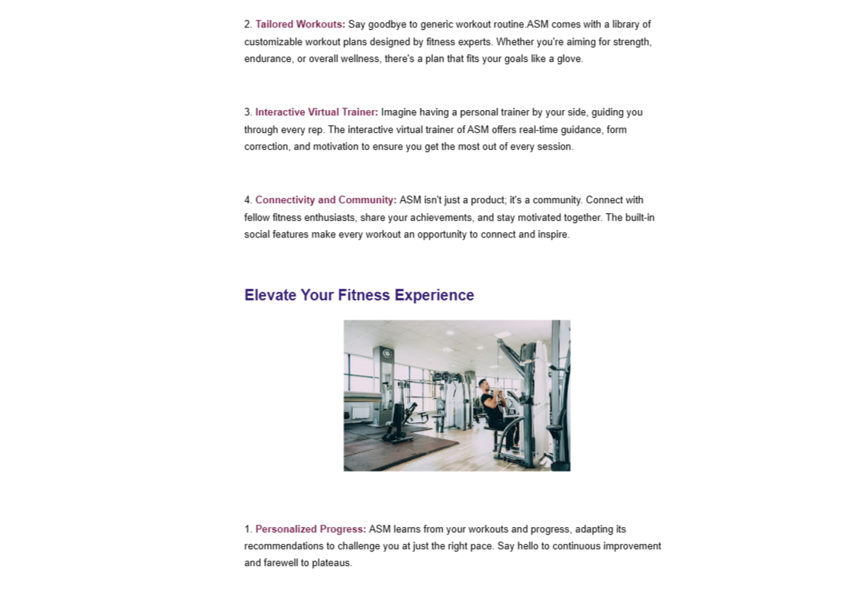

BLOG URL: <https://asmgym.blogspot.com/2023/08/asm-fitness.html>

**ASSIGNMENT – 5**

**EMAIL NEWSLETTER:**

* Understand your audience.
* Choose an email marketing tool.
* Create engaging content.
* Use templates, schedule, and send.
* Track performance for future refinements.

EMAIL NEWSLETTER URL: <https://asmgym.blogspot.com/2023/10/asm-fitness-emailnewsletter.html>

**ASSIGNMENT – 6**

**INFOGRAPHIC POST:**

* Design your infographic.
* Access your Blogger account.
* Create a new blog post and write a title and brief explanation.
* Upload and format your infographic.
* Publish the post and share it on social media.

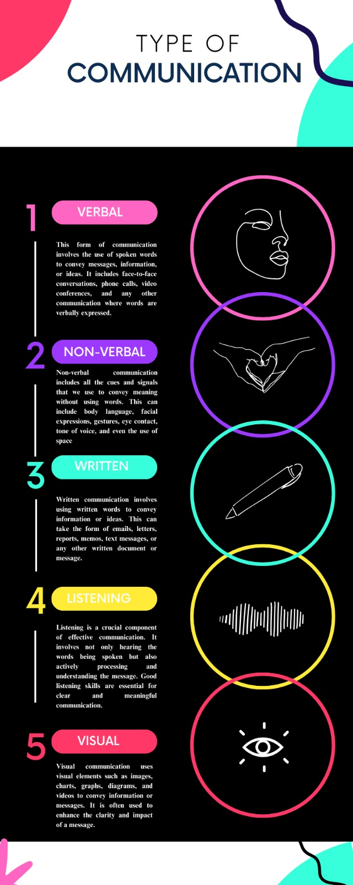

INFOGRAPHIC POST URL: <https://lattelovee27.blogspot.com/2023/09/type-of-communication.html>

**ASSIGNMENT – 7**

**GOOGLE ANALYTICS MEASUREMENT ID:**

**GOOGLE MEASUREMENT ID**: G-NZER2PB6RG

**STREAM ID**: 6329914321